**Experiment Title 2.2**

**Student Name: Sahul Kumar Parida UID: 20BCS4919**

**Branch: CSE Section/Group: WM-904/B**

**Semester: 5th**

**Subject Name: Project Based Learning using Java**

**Subject Code: 20CSP-321**

**1. Aim/Overview of the practical:**

Playing cards during travel is a fun filled experience. For this game they wanted to collect all four unique symbols. Can you help these guys to collect unique symbols from a set of cards?

Create Card class with attributes symbol and number. From our main method collect each card details (symbol and number) from the user.

Collect all these cards in a set, since set is used to store unique values or objects. Once we collect all four different symbols display the first occurrence of card details in alphabetical order.

**2. Software/Hardware Requirements:**

# Windows

# BlueJ (Java IDE)

# JRE (Java Runtime Environment)

**3. Steps for experiment/practical/Code:**

import java.util.*;

class Data implements Comparable<Data>

{

char c;

int num;

Data(char c,int num)

{

this.c=c;

this.num=num;

}

public int compareTo(Data o)

{

if (this.c < o.c)

return -1;

else if (this.c > o.c)

return 1;

else

return 1;

}

public int hashCode()

{

return String.valueOf(c).hashCode();

}

public boolean equals(Object obj)

{

if (obj instanceof Data)

{

Data card = (Data) obj;

return (card.c == this.c);

}

else

{

return false;

}

}

}

public class Exp2_2

{

public static void main()

{

System.out.println("20BCS4919");

System.out.println("Sahul");

Scanner sc=new Scanner(System.in);

HashSet<Data> set=new HashSet<>();

int count=0;

while(count!=4)

{

System.out.println("Enter a card:");

char c=sc.next().charAt(0);

int n=Integer.parseInt(sc.next());

Data obj=new Data(c,n);

if(set.add(obj))

{

count++;

}

}

System.out.println("Four symbols gathered in eight cards.");

System.out.println("Cards in Set are:");

for(Data temp:set)

{

System.out.println(temp.c+" " +temp.num);

}

}

}

**4. Result/Output/Writing Summary:**

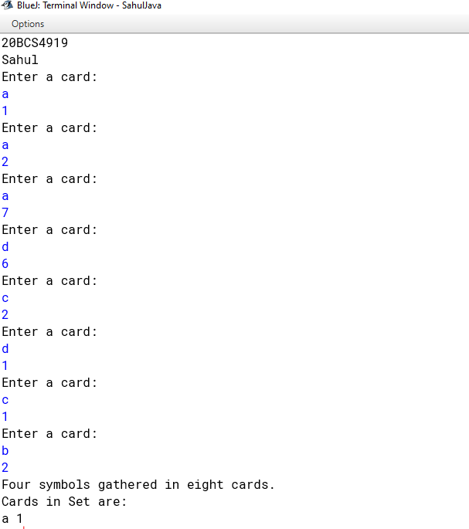

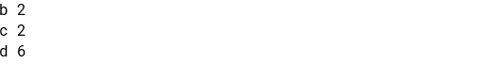

**Learning outcomes (What I have learnt):**

**1. Interface Classes in Java**

**2. Data Structures**

**3. HashSet**

**4. Java If-Else Statement**